BILL SUMMARY
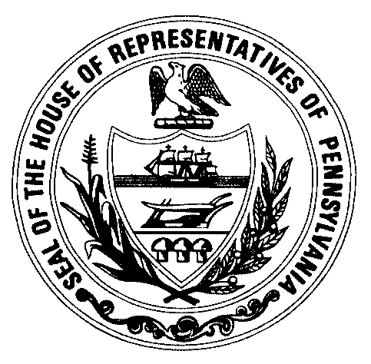
 |  |  |  |  | DATE: | 9/25/17
COMMITTEE: |  | Agriculture |  | BILL NO.: |  | HB 1463
PRIME SPONSOR: |  | Pashinski |  | PRINTER’S NO.: |  | 1868
PREPARED BY: |  | Kerry Golden |  | PHONE NO.: |  | 7-3396

A. SYNOPSIS:

Amends the Dog Law by authorizing an online licensing platform and by increasing license fees and compensation to agents.

B. BILL SUMMARY:

HB 1463 amends the Dog Law to authorize the Secretary of Agriculture to establish a single statewide licensing system using an online platform, capable of maintaining a single statewide registry no matter where and by whom a license is sold. All agents shall submit electronic records of dog license sales to the registry. This system may be operated by a vendor.

County treasurers, their agents, and agents of the Department of Agriculture are currently authorized to sell dog licenses in each county. As compensation for their services, most agents may collect and retain $1 plus the cost of a postage stamp. Agents of the county treasurer collect an additional 50 cents to remit to the treasurer. HB 1463 will establish the agent compensation at $2 for individual licenses and $3 for lifetime licenses, for a period of one year. After that, the secretary has the authority to establish agent compensation by regulation.

For one year, the base cost for a regular individual dog license will increase by $4. Base fees increase according to the following schedule for other types of licenses. After one year, the secretary may establish base license fees by regulation. Compensation cost is additional to the fee schedule outlined below.

Current Fee HB 1463 Fee
Regular dog license $7 $11
Sterilized dog license $5 $8
Regular lifetime dog license $50 $74
Sterilized dog lifetime dog license $30 $44
Senior/disabled regular dog license $5 $8
Senior/disabled sterilized dog license $3 $5
Senior/disabled regular lifetime dog license $30 $44
Senior/disabled sterilized dog lifetime dog license $20 $29

HB 1463 ensures that all fines, fees and costs collected by the Bureau of Dog Law Enforcement will remain in the Dog Law Restricted Account, and not be diverted to the Judicial Computer System Augmentation Account.

Effective Date: Immediately

C. CURRENT LAW:

The Dog Law is Act 225 of 1982.

Title 42 Section 3733 directs certain penalty money from various sources to be deposited into the Judicial Computer System Augmentation Account.

KG/js

