September 26, 2017

I am writing on behalf of the 62,000 member families of Pennsylvania Farm Bureau about House Bill 1463, currently under consideration by the House Agriculture & Rural Affairs Committee.

Pennsylvania Farm Bureau has no opposition to the merits of the bill, and recognizes the need for departments and agencies to periodically raise permit fees to match the rising costs of supervising programs. We note the Pennsylvania Department of Agriculture has not raised license fees since 1996. In addition, we recognize the benefit of modernizing license sales through an online platform.

However, we are concerned that the bill gives the department too broad of authority to impose future increases solely at its discretion by regulation. As a general rule, we believe authority of any agency of the Commonwealth to increase licensing or administrative fees should either be limited by operation of statute or should be subject to prior review and approval by the General Assembly. Our concern is not aimed specifically at the Department of Agriculture, or its proposed dog license fees, but applies across the board to any legislation that would essentially give an agency virtually limitless authority to increase licensing and administrative fees at any time and in any amount, purely at its sole discretion.

Pennsylvania Farm Bureau urges an amendment to HB 1463 to either give the General Assembly greater oversight in future fee increases, or more specifically spell out future fee increases in the legislation.

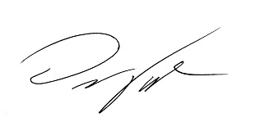
Sincerely,

Darrin Youker
Director, State Government Affairs

